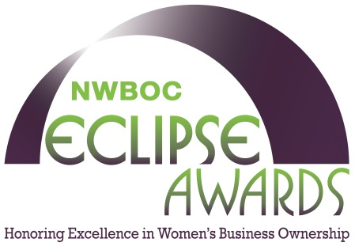
For Immediate Release

Industrial Louvers, Inc. receives Gold Award at NWBOC Decades of Excellence II conference; Unique award program recognizes certified women business owners for outstanding achievements

Lake Park, FLA: (May 15, 2014): Industrial Louvers, Inc., Delano, MN, has been honored with a 2014 Gold NWBOC Eclipse Award for Outstanding Company Culture in the Manufacturing category, according to Janet Harris-Lange, President, National Women Business Owners Corporation (NWBOC), the predominate certifier of woman-owned businesses in the United States. Jo Reinhardt, CEO of Industrial Louvers, received the award which recognizes women business owners that have successfully created an ideal work environment and also participate in their community.

NWBOC Eclipse Awards honorees were announced Thursday evening, May 8, 2014, at the organization’s Decades of Excellence II awards gala at PGA National Resort and Spa, Palm Beach Gardens, Florida. During the evening’s ceremonies, Eclipse awards were presented to a diverse group of women entrepreneurs selected by an esteemed panel of judges. The award program was created by NWBOC to recognize, reward and celebrate the exceptional achievements of certified women business owners, according to Harris-Lange.

Industrial Louvers, Inc. is an architectural metals manufacturer committed to providing the highest quality products and custom designed solutions, with an exceptional level of service. ILI has been a major supplier of architectural louvers, sun control devices, roof top equipment screens and decorative grilles since 1971. Industrial Louvers, Inc. is located at 511 S. 7th St. Delano, MN 55328. For more information please visit our website at www.industriallouvers.com. Contact us at ilinfo@industriallouvers.com or 800-328-3421

Founded in 1995, National Women Business Owners Corporation (NWBOC) leads the way as the nation's first national WBE certifiers. The goal of NWBOC is to increase competition for corporate and government contracts through implementation of a national certification program for women business owners. NWBOC is located at 1001 W. Jasmine Drive, #G, Lake Park, Florida 33403. The web address is www.NWBOC.org. For more information about NWBOC or the Eclipse Award Program, contact Janet Harris-Lange, President, (800) 675-5066 or janet@nwboc.org.
# # #

